Thank You For Your Referral



For more information see our website



[www.hazelwood-dental.com/refer](http://www.hazelwood-dental.com/refer)

Alternatively you can ﬁll in the form below and Email it to us to commence your referral (please retain a copy for your records)

Treatment Required



1

Is there a possibility of pregnancy for

OPG/CBCT? (Mandatory)



5

 Implants

 Oral Surgery  Invisalign

 Root Canal  CBCT

 OPG



YES  NO

Medical History

Please ﬁll in the full details of the treatment requested / Justiﬁcation for radiograph / Area of interest (mandatory)



6



2

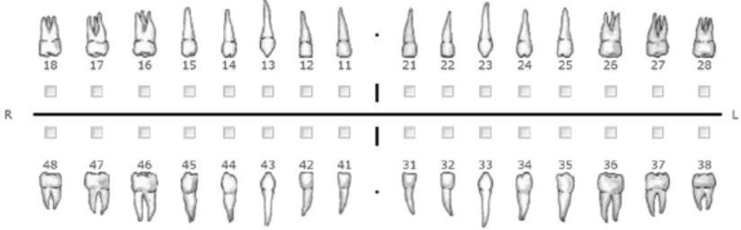

(If no teeth are selected the whole jaw will be scanned)

Patient Details



3

Title Name

D.O.B.

Address

Tel No. Mobile Email

Please state what has been enclosed



4

Referring Dentist



7

Dentist Name Practice Name Address

Tel No. Mobile Email Please provide secure email for return of images

Do you require more referral forms?



8

 YES  NO

*Signature of referring dentist*

 X-Rays

 Medical History Sheet

 Other  Casts

*GDC No. Date*

*\*By Sending this ref you agree to our*

 Are they bringing own Radiographic template?

*standard T&C’s*

020 8882 3180 | [info@hazelwood-dental.com](mailto:info@hazelwood-dental.com) | 5 Hazelwood Lane, Palmers Green, London N13 5EZ